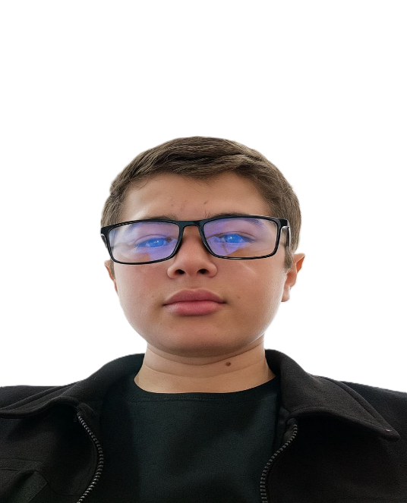

I am creating a website. That delights and pleases people.

About

**Education:**  
 10th grade, Secondary School No. 4

**Address:**  
 Republic of Karakalpakstan, Turtkul district

**Work Experience:**  
 Creating web pages (HTML, CSS, JavaScript)

**Skills:**

✔ HTML, CSS, JavaScript

✔Git, GitHub

✔Figma

✔Tailwind CSS

✔Bootstrap

✔Microsoft Word, Excel

**Languages:**  
 Uzbek - Native;  
 English - Intermediate

**Objective:**  
 To work as a Frontend Developer, contribute to the company's  
 success, and improve my professional skills.

Services

Design that solves problems,

one product at a time  
  

**What I can do for you** **Applications I’m fluent in**

Build fast,interactive,and Every developer needs the modern web applicatons that right tools to bulid great

users love.Here are the apps. Luckily, I know these

services I offer: well:

**▪ Fron-end Development with ▪ React.js**

**React.js ▪ JavaScript**

**▪ Responsive Web Design ▪ Html & Css**

**▪ Performance Optimization ▪Tailwind Css  
 ▪ Api Integration ▪Git & Github**



**What you can expect**

I deliver clean, maintainable, and efficient code

That ensures the best user experience.

**▪ Responsive and user-friendly UI**

**▪ Fast and optimized performance**

**Contact Me**

**Email:polvonbekbaltabaev@gmail.com**

[**Tel:+998**](Tel:+998) **33 656 27 09**